NAAN MUDHALVAN PROJECT

Unlocking Insights into the Global Air Transportation network with Tableau

College: Arignar Anna Government Arts College For Womens, Walajapet,

Ranipet District -632 513

Department Of Mathematics



Unlocking Insights into The Global Air Transportation Network with Tableau

Submitted by

Team Leader: Thamizharasi .V

Team members:

1)Thamizharasi.V

2)Thenmozhi.A

3)Vaishnavi.N.M

4)Valarmathi.A

INRODUCTION

In today’s highly interconnected world,the Global Air Transportation network is a lifeline of travel and commerce. This report dives into the heart of this complex system, employing Tableau’s data visualization prowess.

Our mission: to reveal hidden insights within the vast network of flights,passengers,and airports. Join us as we embark on this journey of data exploration and discovery.

Empathy Map

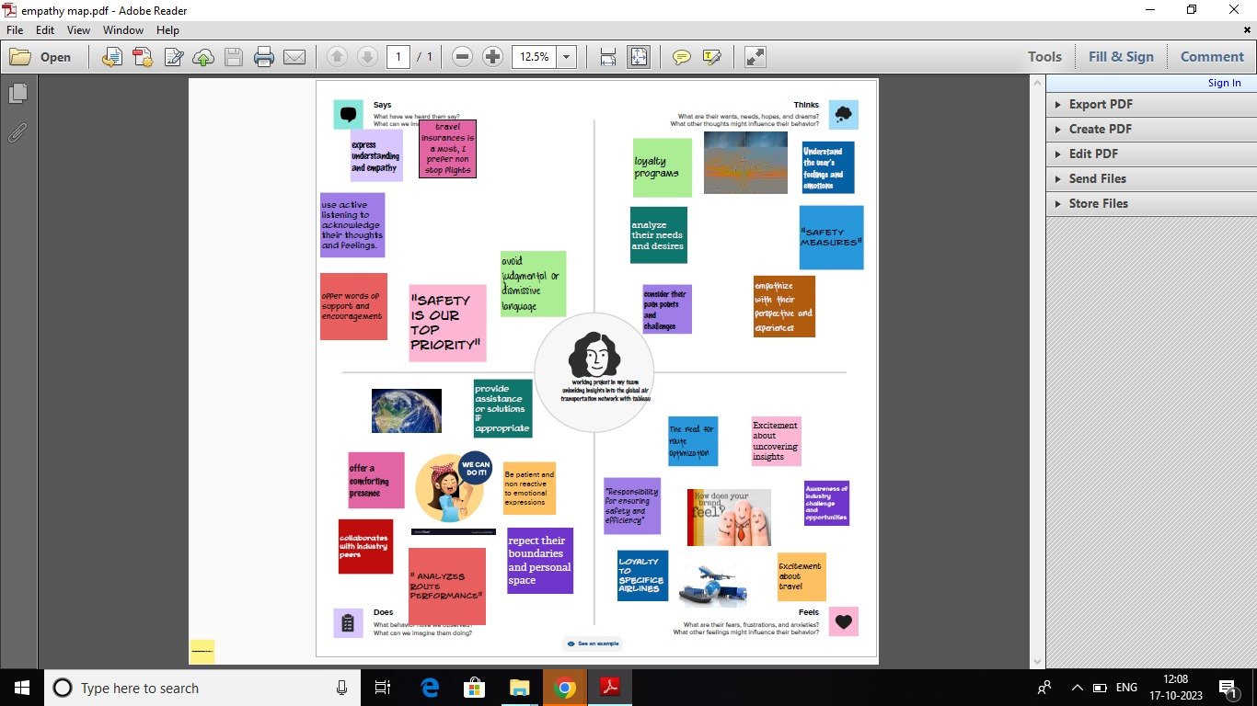

BRAINSTORMING

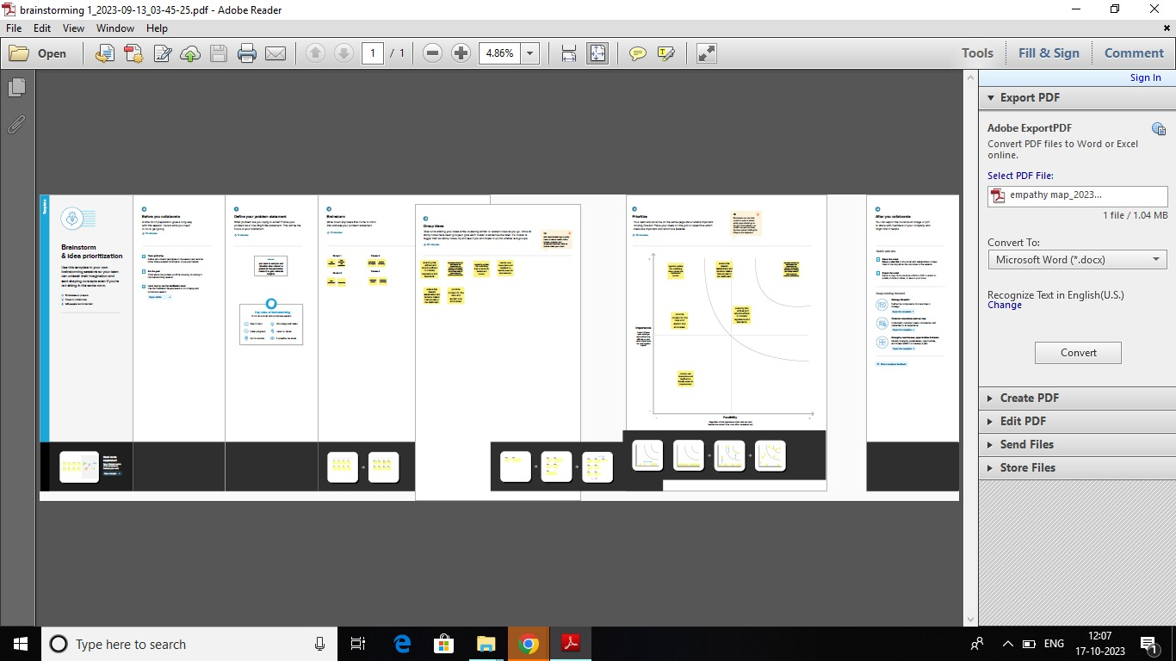

1. We have taken a dataset and we analysis the data by using tableau.
2. Tableau is the most powerful, secure, and flexible end -to -end analytics platform for your data. Elevate people with the power of data.
3. Designed for the individual, but scaled for the enterprise, Tableau is the only business intelligence platform that turns your data into insights that drive action.

DASHBOARD

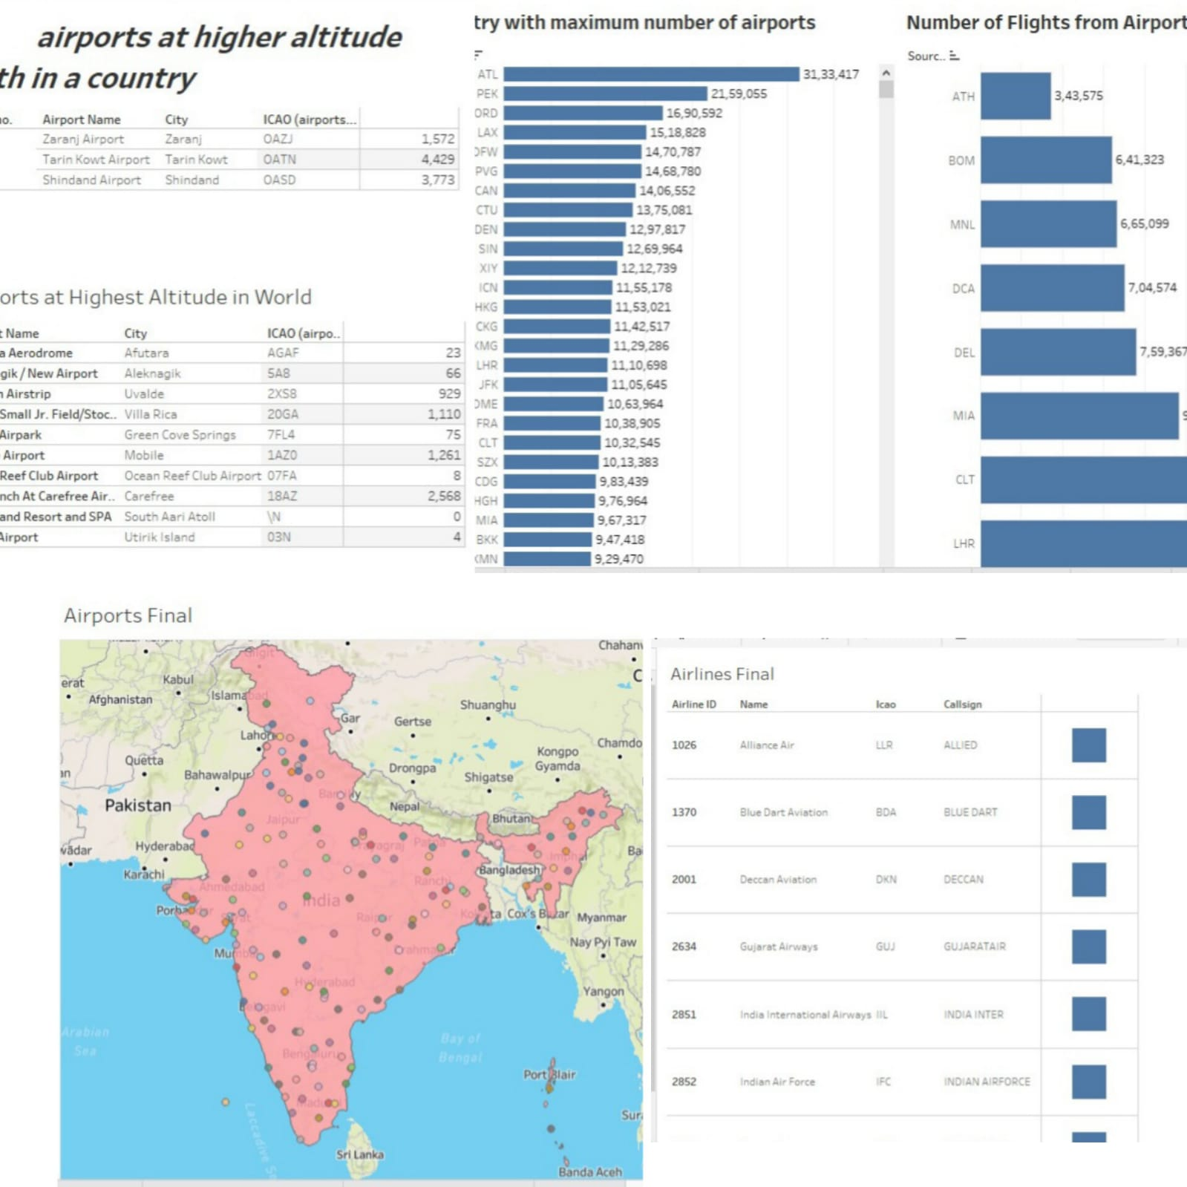

STORY

